**Task: Test Case + Bug Report**

**App Description:** You are tasked with testing the Mahfil app. The app is a mobile application designed to provide users with a platform for streaming unique Islamic content, including waz (sermons), nasheed (Islamic songs), tilawat (Quranic recitation), Islamic shorts, short films, halal documentaries, funny videos, and Islamic lectures. Users can engage with the content by liking, commenting, replying, downloading videos, adding to the wishlist, and updating their profile.

**Download the Mahfil App for Testing:** You can easily download and install the Mahfil app on your device. If you are an Android user, go to Google Play Store and search for "Mahfil."

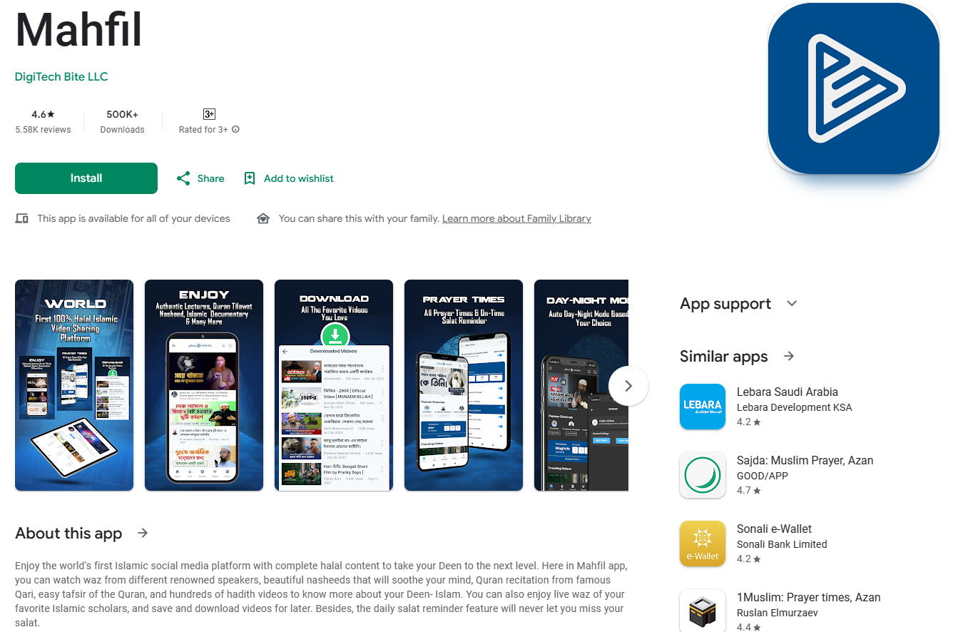

### **Testing Environment:**

* **Mobile app platform:** Android
* **Mobile device or emulator:** Ensure the availability of a suitable device or emulator for testing.

### **Tasks 101: Mahfil App Testing**

1. **User Authentication:**
   * Test the user authentication process by verifying that users can successfully sign up and log in.
   * Ensure that password recovery functionality, if available, works as expected.
2. **Content Categories:**
   * Explore and verify that content categories such as waz, nasheed, tilawat, Islamic shorts, short films, halal documentaries, and funny videos are accessible and correctly organized.
3. **Video Streaming:**
   * Test the video streaming functionality for different types of content.
   * Verify that videos load quickly and play smoothly without buffering issues.
   * Check for features like pause, play, and autoplay.
4. **Unique Video Content:**
   * Verify that the content available on the app is unique and aligns with Islamic principles.
   * Check for any duplicate or inappropriate content.
5. **Download Functionality:**
   * Test the download functionality for videos.
   * Verify that users can download videos for offline viewing.
   * Confirm that downloaded videos play correctly without any issues.
6. **Search and Filters:**
   * Test the search functionality to ensure users can find specific content.
   * Verify that filters (e.g., by category, date, or popularity) work as expected.
7. **User Interaction:**
   * Check for features that allow users to like, comment, or share videos.
   * Verify that user interactions are reflected correctly, and notifications (if any) are generated appropriately.